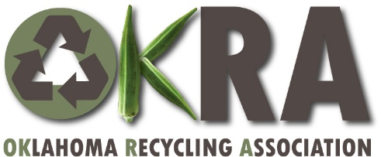

Oklahoma Recycling Conference, “Staying Green in Quarantine”
Wednesday-Thursday, October 7-8, 2020, Zoom Meeting

Support Opportunities:
Support Level | Amount | Number of registrations* | Recognition & publicity** | Logo display during 5-min. Conf. breaks
Metals | $300 | 4 | Yes | 4 breaks
Fibers | $150 | 3 | Yes | 3 breaks
Glass | $100 | 2 | Yes | 2 breaks
Plastics | $75 | 1 | Yes | 1 break
*Conference registrations unused by the sponsor will subsidize Teacher/Class registration fees.
**When listed in publicity, websites, OKRA Newsletter, before, during, or after conference, OKRA will feature support in
order of level.

Conference Registration Fees:
ATTENDEE REGISTRATION TYPE | Wednesday  October 7 | Thursday  October 8 | Both Days
OKRA Member | $10 | $10 | $20
Non-member | $20 | $20 | $40
Teacher/Class | $15 | $15 | $30

To pledge conference support or learn more about it, email info@recycle.org

Online conference registration will be available in September. Check for updates at https://www.recycleok.org/ or www.facebook.com/RecycleOK.org/

8-30-2020

